Exploratory Data Analysis (EDA) Report
Objective
Analyze transactional B2B dataset to uncover sales performance, customer behavior, operational efficiency, and regional trends. Prepare data for modeling and dashboarding.

Data Modelling:
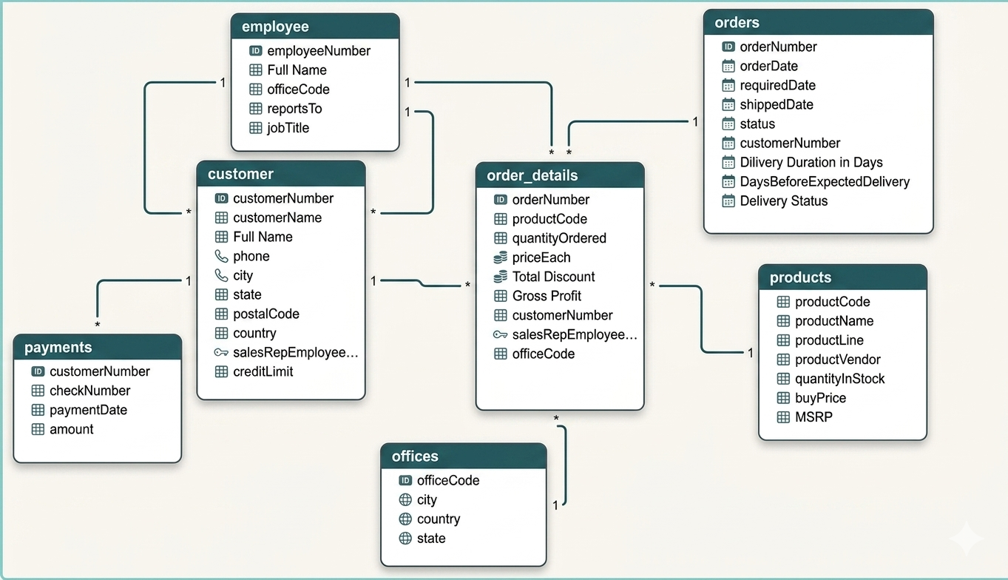
Note: this is the outcome after data preprocessing

Dataset Overview
Table | Rows | Key Columns | Description
customer | 122 | customerNumber | Client master data
employee | 24 | employeeNumber | Sales hierarchy
offices | 7 | officeCode | Regional office mapping
orders | 326 | orderNumber | Order header
order_details | 2996 | orderNumber, productCode | Line-level sales
payments | 273 | customerNumber | Payment transactions
products | 110 | productCode | Product catalog

Data Relationships (Logical Model)
- customer → orders (1:M)
- orders → order_details (1:M)
- products → order_details (1:M)
- customer → payments (1:M)
- employee → customer (via salesRepEmployeeNumber)
- offices → employee (via officeCode)

Data Quality Assessment
Missing / Incomplete Data
- Customer table lacks:
  - Email
  - Website
  - Acquisition channel
- Orders table:
  - No explicit delay metric
- Payments:
  - No linkage to specific orders
- Geography:
  - Inconsistent state/country naming (abbreviations vs full names)
Data Limitations
- Static dataset (2003–2005)
- No real-time updates
- No explicit profit/revenue columns
- No customer segmentation

Feature Engineering (Derived Columns)
Customer-Level Features
- Total Orders = COUNT(orders)
- Total Revenue = SUM(order_details.quantity * priceEach)
- Last Order Date = MAX(orderDate)
- Avg Order Value = Total Revenue / Total Orders
- Customer Lifetime Value (CLV proxy)
- Customer Category:
  - High Value (> threshold)
  - Medium
  - Low
- Loyalty Type:
  - Frequent Buyer
  - Occasional
  - Churned (no orders in last X period)

Order-Level Features
- Revenue = quantityOrdered × priceEach
- Estimated Cost = quantityOrdered × buyPrice
- Profit = Revenue - Cost
- Profit Margin = Profit / Revenue
- Discount (if assumed/derived)
- Shipping Delay = shippedDate - requiredDate
- Shipping Duration = shippedDate - orderDate

Product-Level Features
- Total Sales per Product
- Total Profit per Product
- Inventory Turnover Proxy:
  - quantityOrdered / quantityInStock

Key Metrics to Analyze
Sales & Revenue
- Total Revenue
- Total Profit
- Monthly / Yearly Trends
- Revenue by Product Line
Customer Insights
- Top Customers by Revenue
- Repeat Purchase Rate
- Customer Segmentation Distribution
- Churn Rate
Product Insights
- Best-selling products
- Least-selling products
- High-margin products
Operational Metrics
- Average Shipping Time
- Delay Frequency (% delayed orders)
Geographic Insights
- Revenue by:
  - Country
  - State
  - Territory
- Regional performance comparison

Suggested EDA Steps
1. Univariate Analysis
- Distribution of:
  - Order values
  - Quantity ordered
  - Product prices
  - Credit limits
2. Bivariate Analysis
- Revenue vs Quantity
- Profit vs Product Line
- Orders vs Customer Type
3. Time Series Analysis
- Sales trend (monthly/yearly)
- Seasonality patterns
4. Segmentation Analysis
- RFM (Recency, Frequency, Monetary)
- Customer clustering

Key Observations (Expected)
- Few customers contribute majority revenue (Pareto effect)
- Certain product lines dominate sales
- Some regions underperform
- Shipping delays impact customer experience
- Repeat customers drive stability

Data Cleaning Plan (Power Query)
- Standardize:
  - Country names
  - State names
- Convert date columns to proper format
- Remove duplicates
- Handle null values
- Create calculated columns (Revenue, Profit, Delay)
- Normalize text fields

Data Modeling (Power Pivot)
Fact Tables
- order_details (primary fact)
- payments (secondary fact)
Dimension Tables
- customer
- product
- employee
- office
- date (create calendar table)

Dashboard Strategy
1. Sales Dashboard
- Revenue, Profit KPIs
- Trend charts
- Top products
2. Customer Dashboard
- Customer segmentation
- Top clients
- Purchase behavior
3. Regional Dashboard
- Map visualization
- Revenue by geography
4. Salesperson Dashboard
- Assigned customers
- Revenue per salesperson
- Follow-up indicators (last order date)

